Neural Activations Associated With Friction Stimulation on Touch-Screen Devices

Tactile feedback EEG

【Main Content】：Research on user experience using EEG tactile feedback.

·Designed an active touch task using a tactile touchscreen device while recording the EEG signals during the experiment. EEG (Yeon et al., 2017) examined the texture correlation of the brain during passive and active touch tasks.

·TanvasTouch1 developed a tactile touch screen device to provide frictional stimulation. This stimulation is achieved by adjusting the surface friction between the fingertip and the physical display panel to simulate surface texture.

·An initial network connection is established between the Presentation software and the haptic touch screen device. After a successful connection, the Presentation software then controls the friction stimulus function on the touch screen device with an activation message. A 64-channel EEG device was used to record neural activity in active touch tasks.

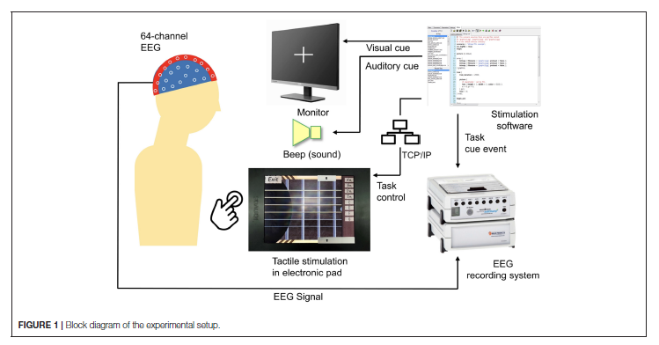

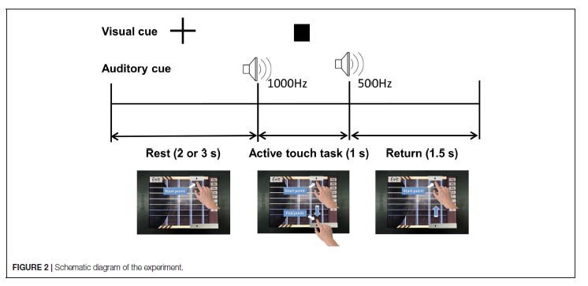

**Tactile is divided into active and passive tactile:**

Touch interaction is classiﬁed as either passive or active. In passive touch, physical contact is controlled by an external party (environment or other human), such as when a friend taps us on the shoulder. On the other hand, active touch involves the active use of human body to explore the environment (such as when stroking a surface to learn about its texture). Interaction with a touch-screen device involves mainly active touch. A signiﬁcant neuroscience research on touch has focused on the neuronal circuits that compare passive and active touch (Harsimrat Singh et al., 2014; Moungou et al., 2016). Studies found that active touch induces diﬀerent neural mechanisms as compared to passive touch .

【Subjective analysis】：

**Advantage:**

Quantitative studies on tactile feedback were performed using EEG signals from EEG [EEG (Yeon et al., 2017)]. Reflects the objectivity of the experiment. By analyzing the EEG signals with and without friction, we conclude:

1) Neural activity differs with and without friction, and this result is similar to the subjective evaluation of participants

2) Friction stimulation plays an important role in focusing attention on interaction with touch screen devices

3) Analysis of the differences in EEG signals in different regions of the brain in the above experiments

**Disadvantages:**

1. This article is based on the haptic feedback screen developed by TanvasTouch. This screen is based on the principle of electrostatic haptic feedback. However, in the experiment, there is no comparison with other devices that generate haptic feedback, such as electromechanical, piezoelectric, etc., so it is not completely certain that the change in the EEG signal is caused by the generated haptic feedback.

2) This article just illustrates that haptic feedback can have a positive effect focus on touch screens. However, it does not say whether haptic feedback can improve the user operation experience.

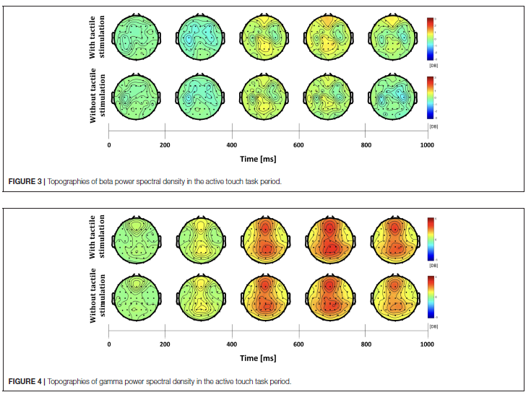

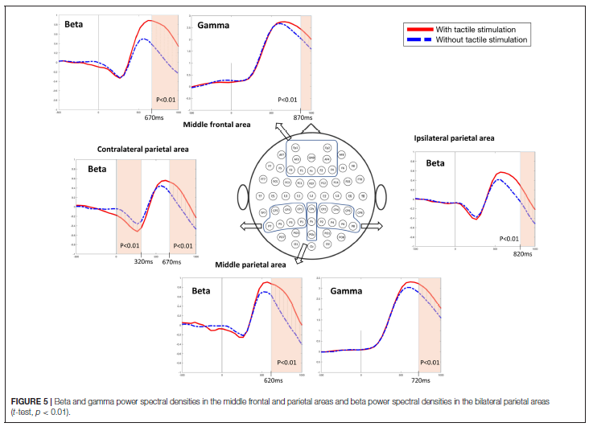

【Important Reference】:

Yatani, K., and Truong, K. (2007). “An evaluation of stylus-based text entry methods on handheld devices instationary and mobile settings,” in 9th International Conference on Human Computer Interaction With Mobile Devices and Services, 487–494.